**Task 12**

Create a custom docker image for nginx and deploy it using docker-compose, where the volume mount should be at /var/opt/nginx location. Push the created custom docker image to your docker hub.

Mounting

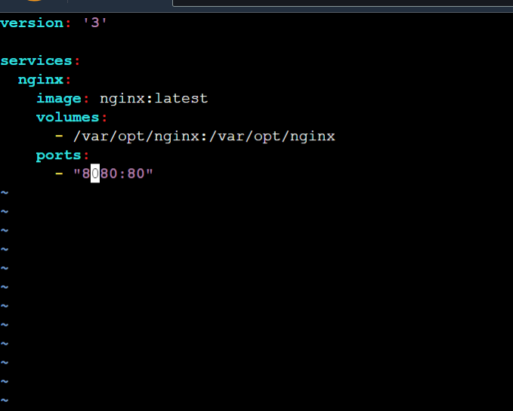

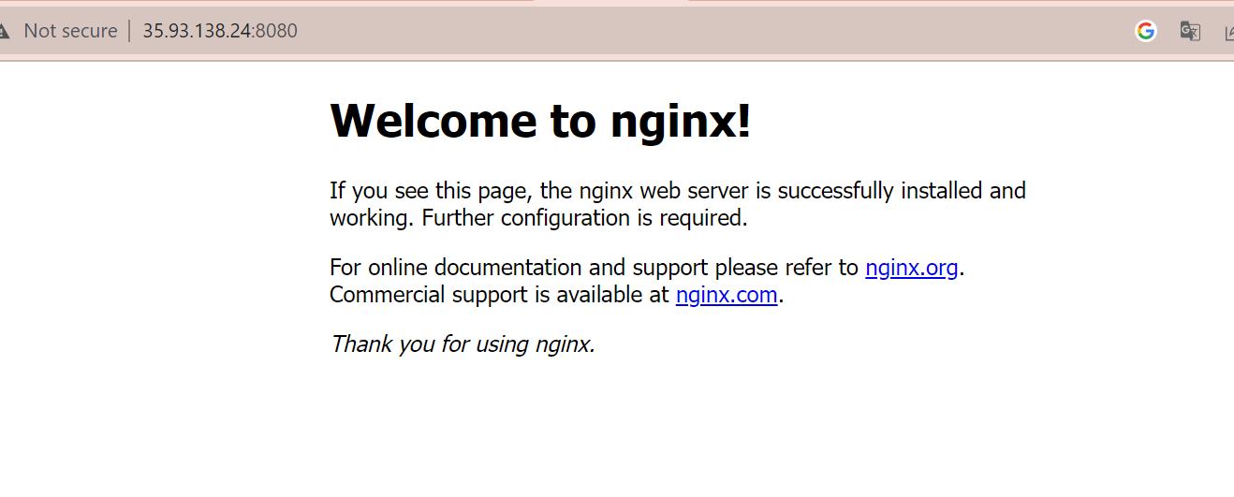

**Creating docker ingnix image**

